Density is defined as the ratio of the mass of a given sample of a substance (M) to its volume (V). It is usually measured in units such as kg/m³, g/cm³, or g/mL.
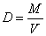
Reading a Density Graph Name: _________________

Use the graph of Mass vs. Volume to answer the questions.
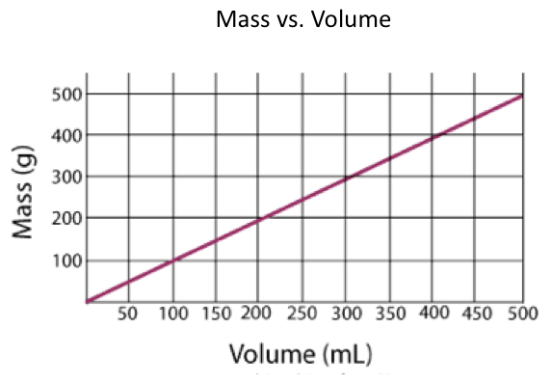
mL = cm³
A
B
C
- As the volume of a sample increases A from 200 cm³ to 300 cm³, how does the mass change? (support your answer with data)

- Find the density of samples A, B and C.

3. For sample B, estimate the change in volume if the mass increases from 100 g to 400 g. Cite data from the graph using a full sentence(s).

4. Based the chart below, what substance was represented by the data displayed on the graph? The densities are measured in g/mL or g/cm³ . The small letters represent the state of the substance at room temperature: solid, liquid, or gas. SUPPORT YOUR ANSWER WITH DATA.

Substance | Density (g/cm³)
Hydrogen(g) | 0.00009
Mercury(l) | 13.5
carbon(s) | 2.3
ammonia(g) | 0.008
water(l) | 1.00
sucrose(s) | 1.6

