Density calculations Name: _____________
Score: ____/ 50

SET ONE
Solve the problems below with the density formula. Use the Guess problem solving method on all problems.

$d=\frac{m}{V}$ where m is measured in grams and V is measured in cm³ or mL.

- Find the density of a box with a mass of 27 grams and a volume of 3 milliliters.
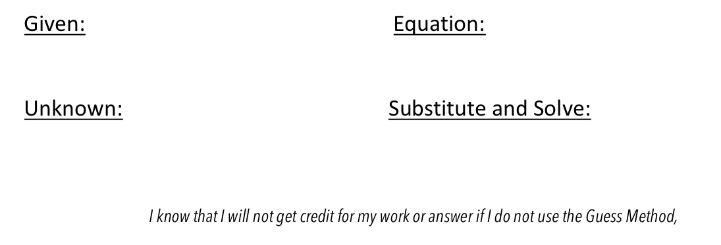
2. Find the density of a crate with a mass of 50 grams and a volume of 2 milliliters
3. Find the density of a ball with a mass of 8 grams and a volume of 4 milliliters
4. Find the density of a package with a mass of 5 grams and a volume of 10 milliliters
5. Find the density of a rock with a mass of 150 grams and a volume of 3 milliliters

Check your work on this section at: https://quizlet.com/149800467/flashcards

SET TWO
Solve the problems below with the formula for a rectangular prism. Use the Guess problem solving method on all problems.

$V=l w d$ where l, w and d are measured cm.

- Find the volume of a rectangle that is 3 cm tall, 4 cm wide and 2 cm deep.
- What is the volume of a 56 cubic centimeter object in milliliters (mL)?
- What is the volume of a cube with edges 5 cm in length?
- Find the volume of a box that is 1 cm tall, 5 cm deep and 6 cm wide.
- What is the volume of a cube with edges 2 cm in length?

Check your work on this section at: https://quizlet.com/149803253/flashcards

SET THREE
Solve the problems below with the density formula. Use the Guess problem solving method on all problems.

$d=\frac{m}{V}$ where m is measured in grams and V is measured in cm³ or mL.
$V=l w d$ where l, w and d are measured cm.

- Find the density of 36 gram box rectangle that has dimensions of 2 cm by 3 cm by 2 cm.
- Find the density of a cube that has a mass of 32 grams if the edges are 2 cm long.
- Find the density of a cube that has a mass of 250 grams if the edges are 5 cm long.

Check your work on this section at: https://quizlet.com/149806977/flashcards

SET FOUR
Solve the problems below with the density formula solved for mass. Use the Guess problem solving method on all problems.

$m=d V$ where d is measured in grams/mL and V is measured in cm³ or mL.

- Find the mass of a rock if its density is 5 grams/ mL and its volume is 11 mL.
- You have a sample of a substance that has a density of 180 grams/mL. What is the mass of the sample if its volume is 2 mL?
- A block of plastic has a volume of 9 mL. Find its mass if the density of the plastic is 3 grams/mL.

Check your work on this section at: https://quizlet.com/149816238/flashcards

SET FIVE
Solve the problems below with the density formula that is solved for mass. Use the Guess problem solving method on all problems.

$V=\frac{m}{d}$ where m is measured in grams and d is measured in g/cm³ org/ mL.

1. Find the volume of a sample if it has a density of 90 grams/mL. The sample's mass is 45 grams.
2. You measure the mass of a rock as 160 grams. If this type of rock has a density of 10 grams/mL, find the volume of the rock.
3. You know that oil has a density of 0.9 grams/mL. If you have a container with 90 grams of oil, what is the volume of the oil?

SET SIX
For these problems, you will need to select the appropriate equation. Solve the problems below with the density formula. Use the Guess problem solving method on all problems.

$d=\frac{m}{V}$ $V=\frac{m}{d}$ $m=d V$
where m is measured in grams, V is measured in cm³ or mL and d is measured in g/cm³ or g/mL

- You have a 30 mL rock with a mass of 60 grams. What is its density?
- A 800 gram sample has a density of 200 grams/mL. What volume is the sample?
- A cube with 3 cm edges has a density of 2 grams/mL. What is the mass of the cube?
- A sphere with a density of 7 grams/mL has a mass of 56 grams. What is the volume of the sphere?

Check your work on this section at: https://quizlet.com/149827243/flashcards

