 | Topic/Objective:  Accuracy & Precision  Significant Figures | Name:
 |  | Class/Period:
 |  | Date:
Essential Question: I express the accuracy and precision of my lab measurements using significant figures.
BOP: Pages 6 and 7
Questions: | Notes:  Accuracy is  How close a value is to the true value.  And is determined by Selecting the a tool with finer calibration.  Precision is How close repeated values are to one another  And is Reflects the calibration of the measuring tool .  Both Accuracy and Precision depend on the Calibration and the quality of the measuring tool.  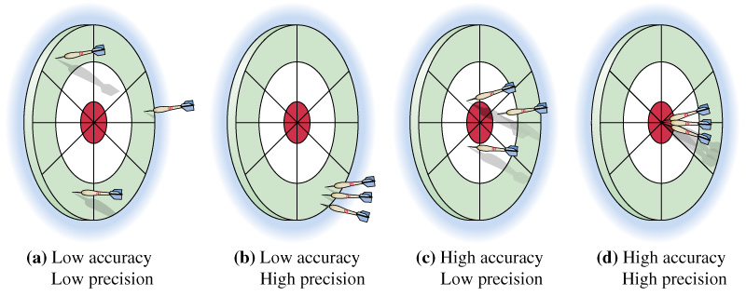  ___ accuracy  ___ precision  ___ accuracy  ___ precision  ___ accuracy  ___ precision  ____accuracy  ____precision  The competence of the experimenter can influence both accuracy and precision.
Summary:
Significant Figures are the number of digits that ‘count’.

The trick to Sig figs is knowing when to count ZERO’S
And when to ignore them.
Rule one: All non-zeroes are Significant (they count).
56,764.3 has 6 sig figs. 2 has 1 sig fig.
Rule two: All zeroes are Significant (they count) if they are .between non-zeroes.
605 has 3 sig figs. 80,704 has 5 sig figs.
Rule three: All zeroes are Significant (they count) if they are . on the right AND there is a decimal point .
280,000. has 6 sig figs. 8070. has 4 sig figs.
280,000 has 2 sig figs. 8070 has 3 sig figs.
Rule four: Zeroes are NOT Significant (they do not . . count) if they are on the left EVEN IF
. there is a decimal point .
0.007 has 1 sig figs. 0.007000 has 4 sig figs.
280.000 has 6 sig figs. 0.9 has 1 sig figs.

When you multiply and divide sig figs, round the answer to the least number of sig figs.
40 * 12.0 = 480 but the correct sig fig answer is 500.
STEPS:
- Complete the multiplication or division
- Count the sig figs in the values you started with.
- Select the lowest number of sig figs.
- Round your answer to the lowest number of sig fig’
Summary:

