 | Topic/Objective:  Accuracy & Precision  Significant Figures | Name:
 |  | Class/Period:
 |  | Date:
Essential Question: I express the accuracy and precision of my lab measurements using significant figures.
BOP: Pages 6 and 7
Questions: | Notes:  Accuracy is ________________________________________________________.  - Reflects the __________________ of the measuring tool.  - The experimenter can improve accuracy by  Selecting ___________________________.  Precision is ________________________________________________________.  - Reflects the _______________ of the experimenters.  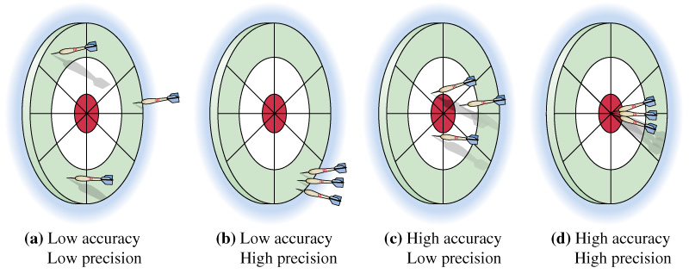  ___ accuracy  ___ precision  ___ accuracy  ___ precision  ___ accuracy  ___ precision  ____accuracy  ____precision  Significant Figures are the number of ______________ that ‘count’.  The trick to Sig figs is knowing when to count ____________  And when to _______________ them.
Summary:
Rule one: All non-zeroes are_______________ (they count).
56,764.3 has _____ sig figs. 2 has ____ sig fig.

Rule two: All zeroes are _______________ (they count) if they are . _____________ non-zeroes.
605 has ______ sig figs. 80,704 has _____ sig figs.

Rule three: All zeroes are _______________ (they count) if they are . on the ____________ AND
. there is a __________________.
280,000. has ____ sig figs. 8070. has ___ sig figs.
280,000 has ____ sig figs. 8070 has ___ sig figs.

Rule four: Zeroes are NOT _______________ (they do not . . count) if they are on the ____________ EVEN IF
. there is a __________________.
0.007 has ____ sig figs. 0.007000 has ___ sig figs.
280.000 has ____ sig figs. 0.9 has ___ sig figs.

When you multiply and divide sig figs, round the answer to the least number of sig figs.
40 * 12.0 = 480 but the correct sig fig answer is ______________.
STEPS:
- Complete the multiplication or division
- Count the sig figs in the values you started with.
- Select the lowest number of sig figs.
- Round your answer to the lowest number of sig fig’
Summary:

